WEEK 3 TASK
Python-Based Machine Learning Model Development and Evaluation Plan
Hypothetical Problem:
Classifying Pre-Harvest Crop Yield Risk (Low / Medium / High) from Weather and Soil Data
Data Science Internship – ML Model Development & Evaluation Report

1. Problem Definition
Building on the crop yield context from earlier tasks, this plan reframes the problem as a classification task: predicting a pre-harvest crop yield risk category — Low, Medium, or High risk — for a given district and season, using weather and soil data available before the harvest.
Why classification: A risk category is more directly actionable for farmers and cooperatives than a raw yield number. A 'High risk' alert several weeks before harvest can prompt timely irrigation, input adjustments, or insurance decisions, whereas a precise yield estimate is only useful much closer to (or after) the season ends.
The target variable would be constructed by binning historical yield-per-hectare values into three risk tiers (e.g., bottom, middle, and top tercile relative to a district's historical average), turning this into a supervised multi-class classification problem well suited to standard evaluation metrics like accuracy, precision, recall, F1-score, and ROC-AUC.

2. Data Preprocessing
The dataset would combine the same weather, soil, and historical yield sources used in Weeks 1–2, now processed specifically for model input. The table below summarizes the planned preprocessing pipeline.
Step | Technique | Purpose
Cleaning | Impute missing values, remove duplicates, fix inconsistent labels | Ensure model trains on reliable, consistent records
Normalization | Min-Max scaling or StandardScaler on numeric features (rainfall, temperature) | Prevent features with larger numeric ranges from dominating distance-based models
Encoding | One-hot encoding for crop type and soil category | Convert categorical fields into a numeric format models can use
Feature Engineering | Derived features: cumulative rainfall, drought-day count, temperature range | Capture patterns raw variables alone would miss
Feature Selection | Correlation filtering, feature importance from a baseline tree model | Reduce noise and overfitting risk from irrelevant features
Class Balancing | Class weighting or SMOTE if risk categories are imbalanced | Prevent the model from favoring the majority risk class
Table 1: Data preprocessing steps for the classification pipeline

2.1 Anticipated Preprocessing Challenges
- Class imbalance: 'Medium risk' seasons are typically more common than extreme 'Low' or 'High' risk seasons — addressed via class weighting during training.
- Feature leakage risk: care must be taken to exclude any post-harvest information from features, since the model must predict risk before harvest.
- Small per-district sample sizes: mitigated by pooling similar districts (based on agro-climatic zone) to increase effective training data.

3. Model Selection and Training
Several model families are considered, ranging from simple and interpretable to more complex ensemble methods. The diagram below maps the candidate models considered for this classification task.
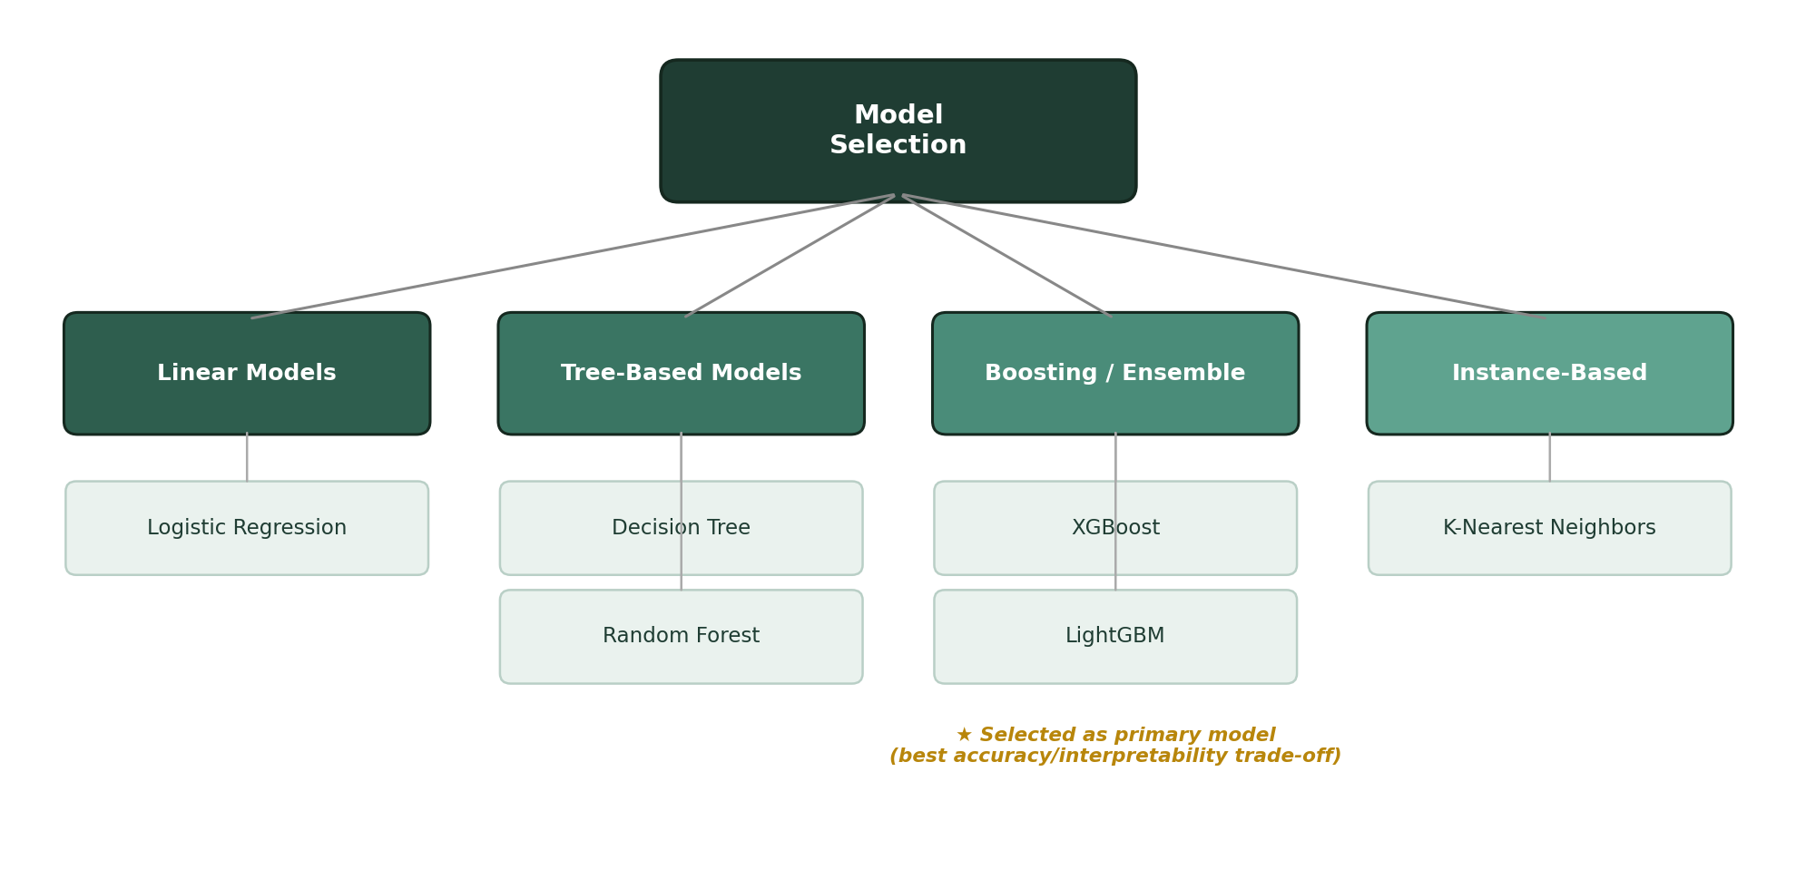
Figure 1: Candidate models considered for pre-harvest risk classification

3.1 Model Justification
Logistic Regression serves as an interpretable baseline, useful for sanity-checking feature relationships. Random Forest and XGBoost are the primary candidates: both handle non-linear interactions between weather and soil variables well, and XGBoost in particular is proposed as the primary model given its strong track record on small-to-medium tabular datasets and its built-in feature-importance output, which supports the explainability goal from Week 1.

3.2 Training Process & Hyperparameter Tuning
- Split data into training (70%), validation (15%), and test (15%) sets, stratified by risk category to preserve class balance.
- Use k-fold (k=5) cross-validation on the training set to tune hyperparameters, minimizing the risk of overfitting on a limited dataset.
- For XGBoost, tune max depth, learning rate, number of estimators, and subsample ratio via grid or randomized search.
- Hold out the test set strictly for final evaluation only, never used during tuning.

4. Evaluation Metrics
Since this is a multi-class classification problem with an actionable minority class ('High risk'), evaluation goes beyond simple accuracy to include metrics that reflect the real-world cost of different error types.
Metric | What It Measures | Why It Matters Here
Accuracy | Proportion of all predictions (Low/Medium/High risk) that were correct | Quick overall sanity check, but misleading alone if risk classes are imbalanced
Precision | Of all seasons predicted 'High risk', how many actually were | Avoids over-alarming farmers with false high-risk warnings
Recall | Of all seasons that were actually 'High risk', how many were caught | Missing a genuine high-risk season is costlier than a false alarm
F1-Score | Harmonic mean of precision and recall | Balances both concerns into a single comparable number across models
ROC-AUC | Model's ability to separate risk classes across all decision thresholds | Useful for comparing models independent of a chosen probability cutoff
Table 2: Evaluation metrics and their relevance to the risk-classification task

4.1 Validation Strategy
Stratified k-fold cross-validation ensures each fold preserves the proportion of Low/Medium/High risk seasons, giving a more reliable estimate of real-world performance than a single train/test split — particularly important given the relatively small number of historical seasons available per district. A confusion matrix would be reviewed alongside these metrics to understand exactly which risk categories the model tends to confuse.

5. Model Deployment (Optional)
While full production deployment is outside this project's scope, this section conceptualizes how the model could eventually be maintained:
- Package the trained model with a versioned artifact (e.g., using joblib or ONNX) alongside the preprocessing pipeline, so both travel together.
- Re-train on a scheduled basis (e.g., after each harvest season) as new labeled data becomes available, following the feedback loop shown in Figure 2 of Week 1's methodology.
- Monitor prediction drift by comparing incoming season's weather/soil feature distributions against the training data distribution.
- Expose predictions through a simple API or dashboard that agricultural extension officers could query per district ahead of each season.

6. Conclusion
This plan lays out a complete strategy for developing and evaluating a machine learning classifier that turns weather and soil data into an actionable, pre-harvest risk signal. By pairing a strong candidate model (XGBoost) with a validation strategy suited to a small, imbalanced dataset, and evaluation metrics that reflect real-world stakes, this approach is designed to produce a model that is both accurate and trustworthy enough for practical use by farmers and cooperatives.

